AUTOMATION USING SELINIUM AND DOCKER PROJECT

Name: Sravani Manne

Emp id: 201350

E-mail: Sravani.manne@amdocs.com

CONTENTS:

* Selenium
* Spring boot
* Docker

INTRODUCTION:

SELENIUM:

* Selenium is one of the most widely used opensource Web UI automation testing suite.
* It supports automation across different browsers, platforms and programming languages.
* It supports a variety of programming languages through the use of drivers specific to each language.

DOCKER:

* Docker is an open platform for developing, shipping, and running applications.
* It enables us to separate our applications from the infrastructure so one can deliver software quickly.
* Using docker one can manage infrastructure as well as applications.
* By taking advantage of Docker's methodologies for shipping, testing, and deploying code, one can significantly reduce the delay between writing code and running it in production.

AUTOMATING USING SELENIUM:

* Creating simple web driver and importing required libraries.

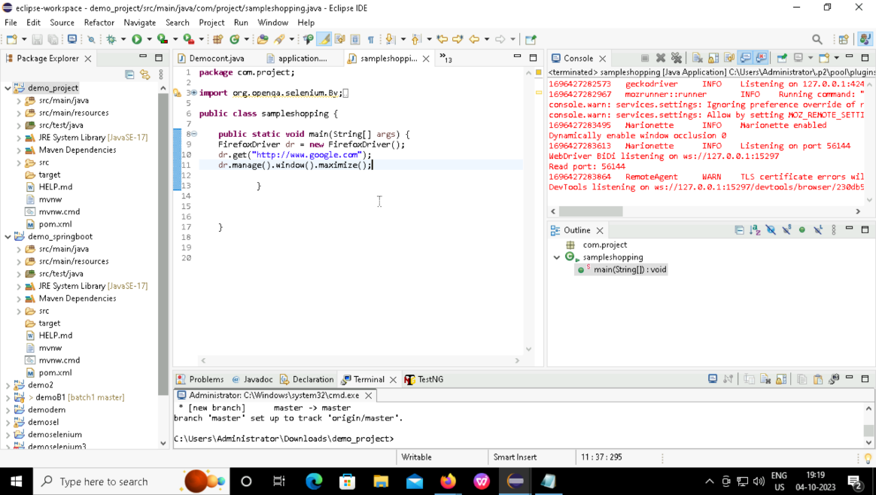

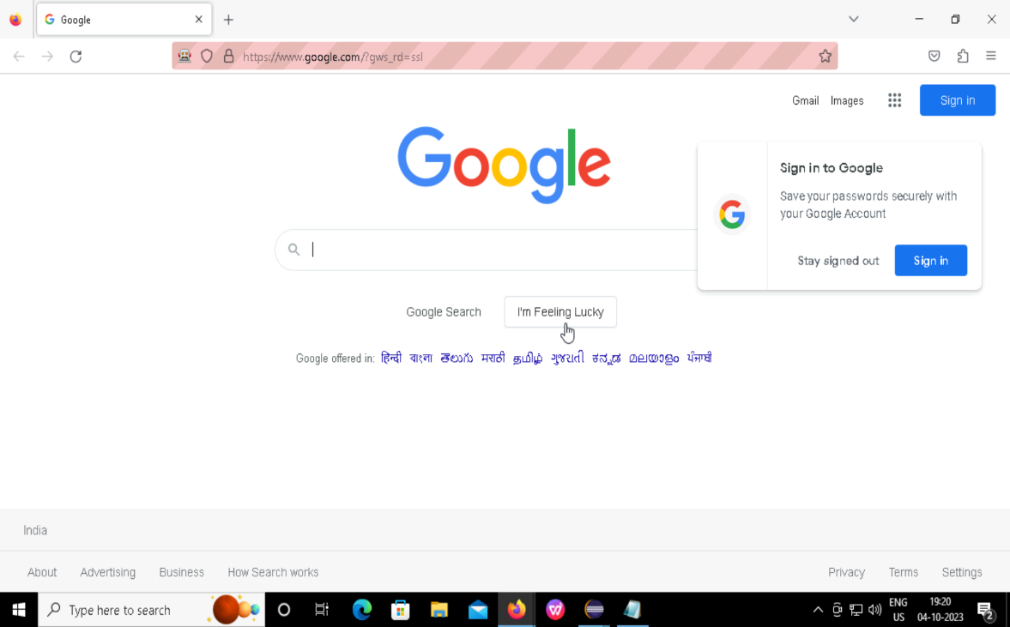

* Automating website “amazon”.

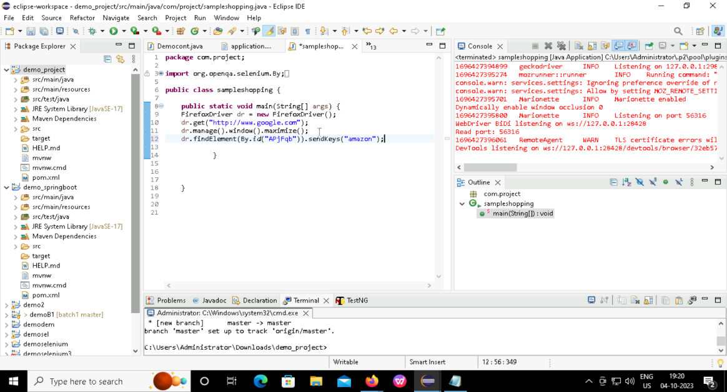

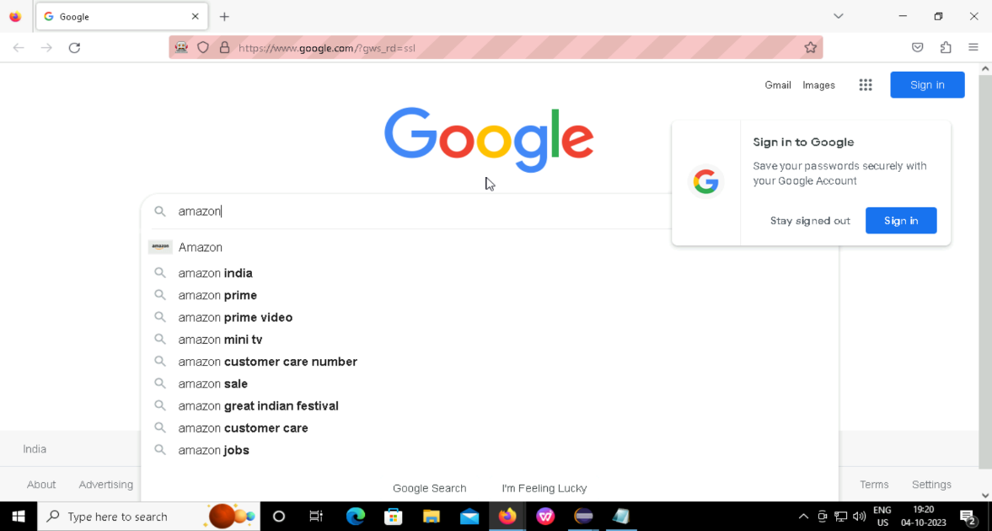

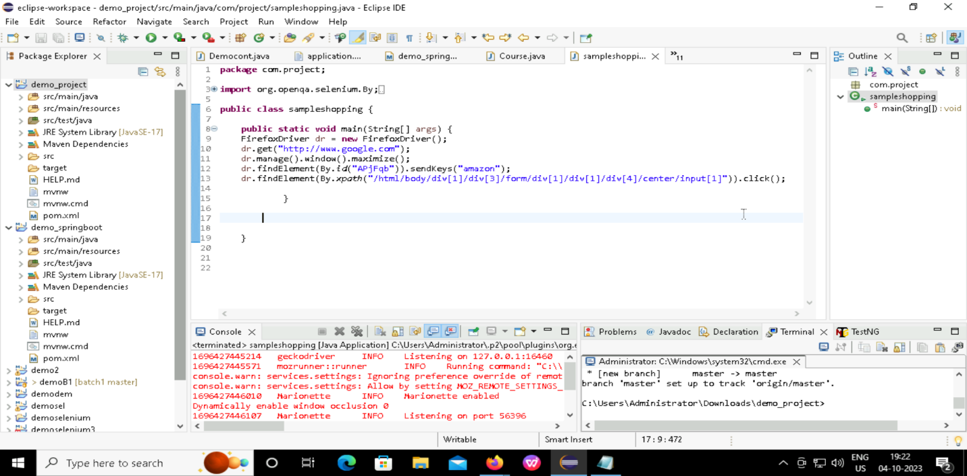

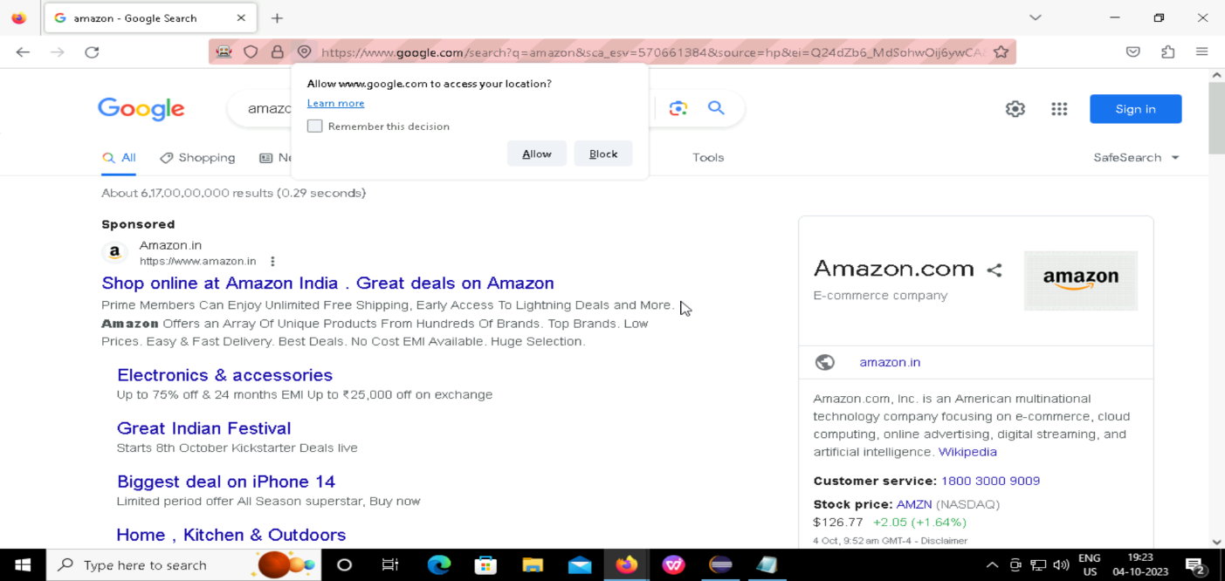

* Next searching for the product “Mobile”.

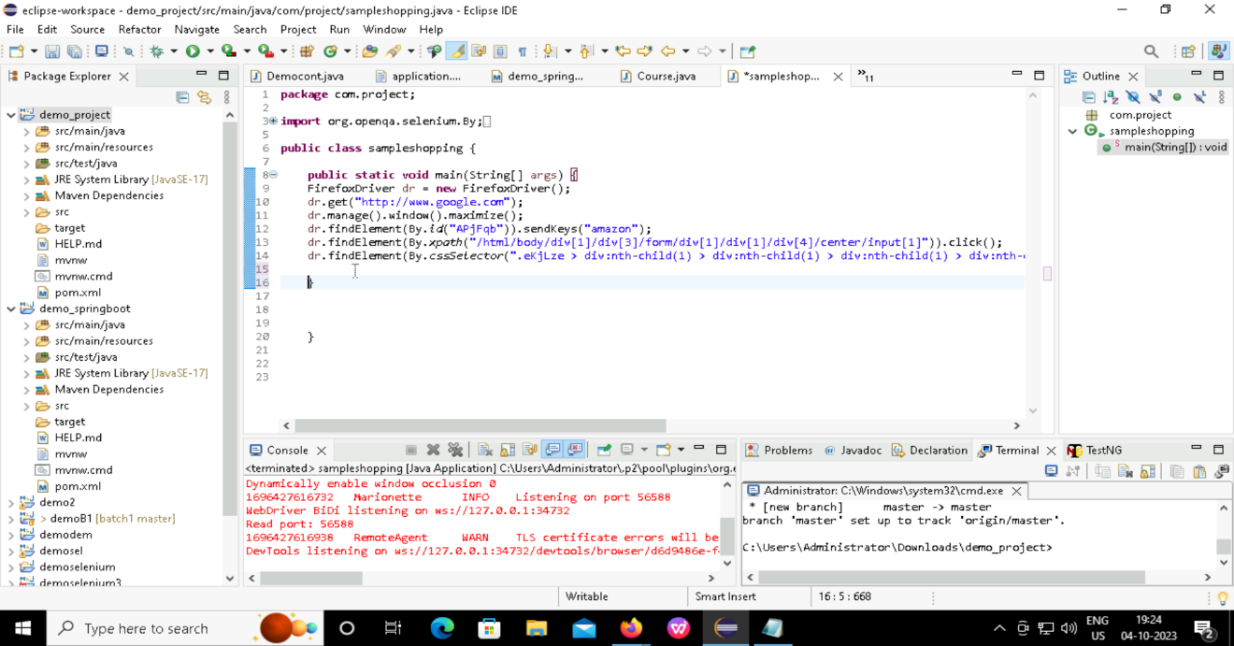

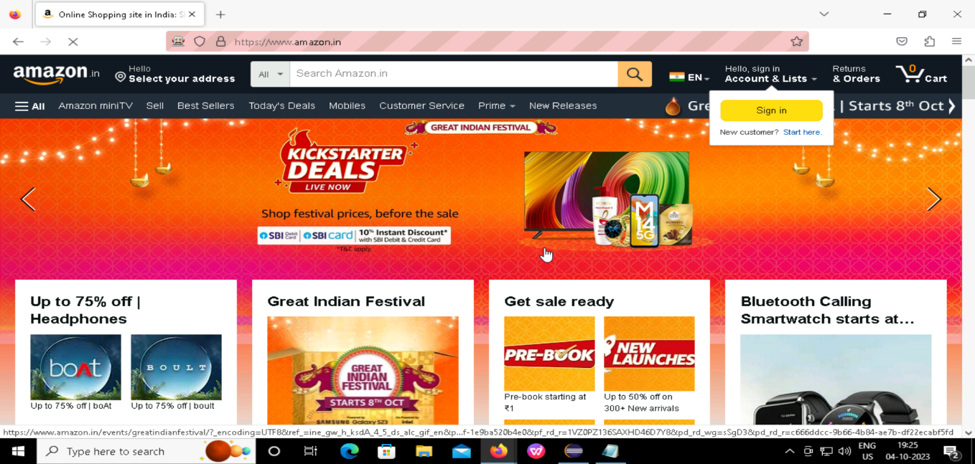

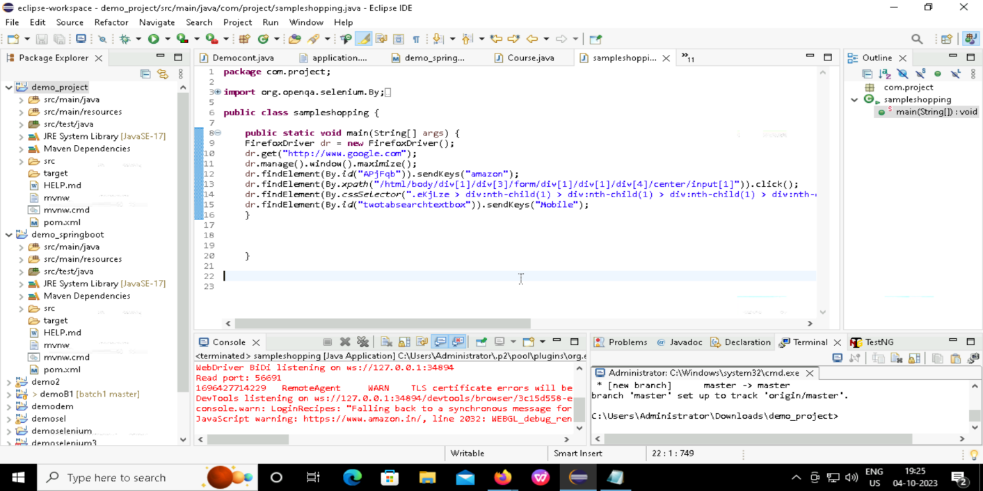

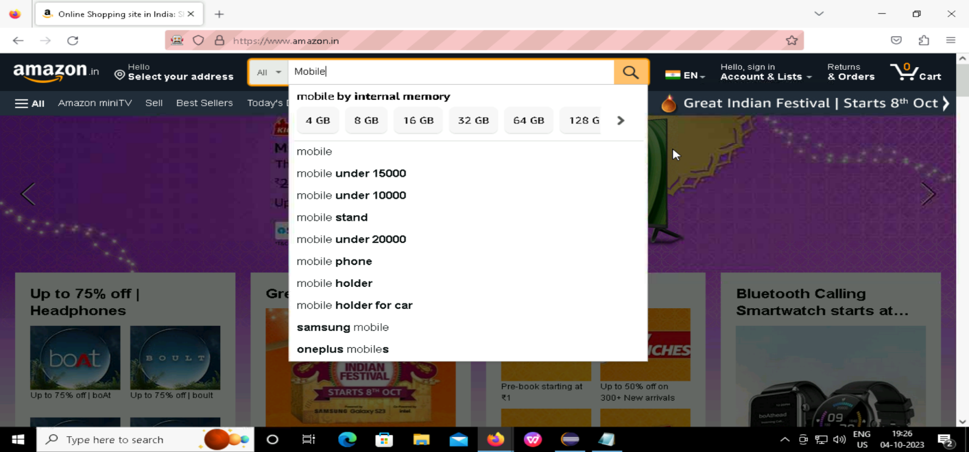

* Search for mobile and mobile brand.

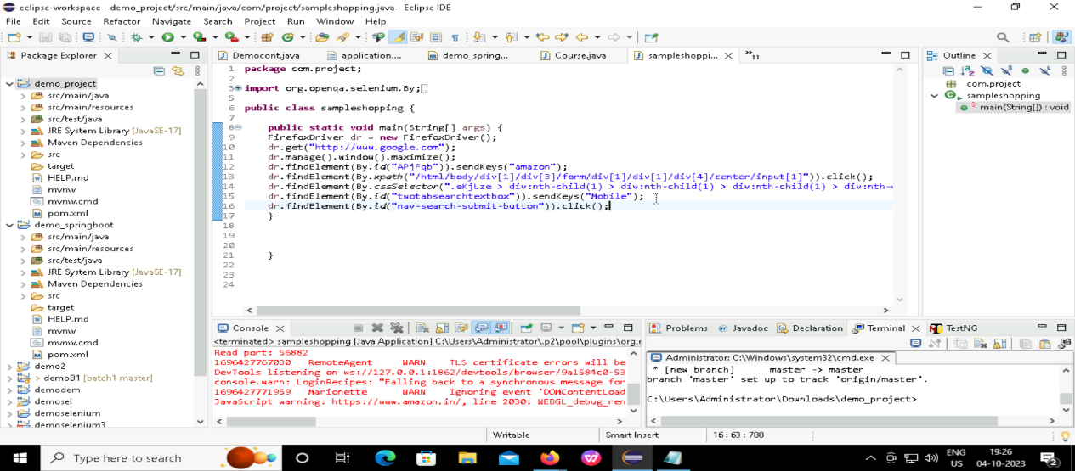

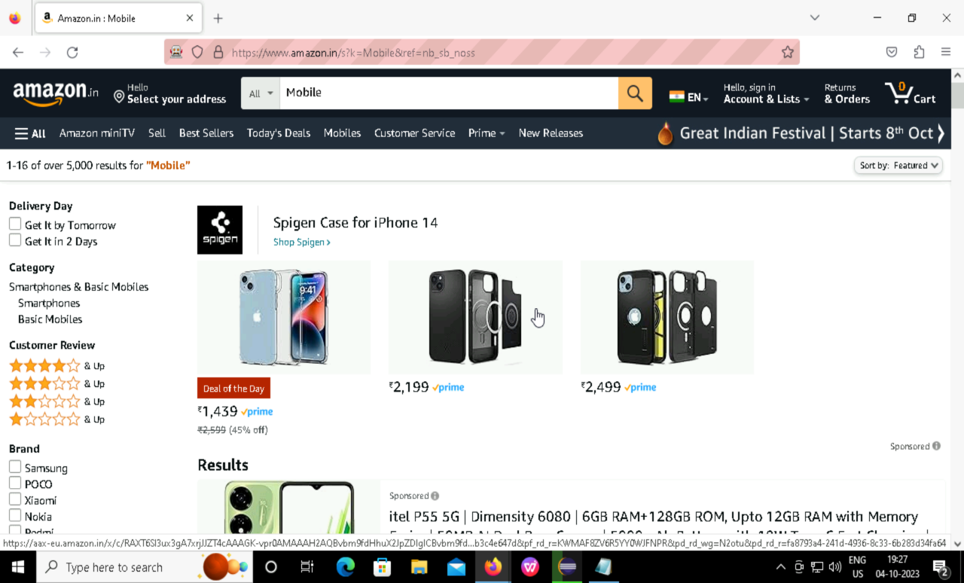

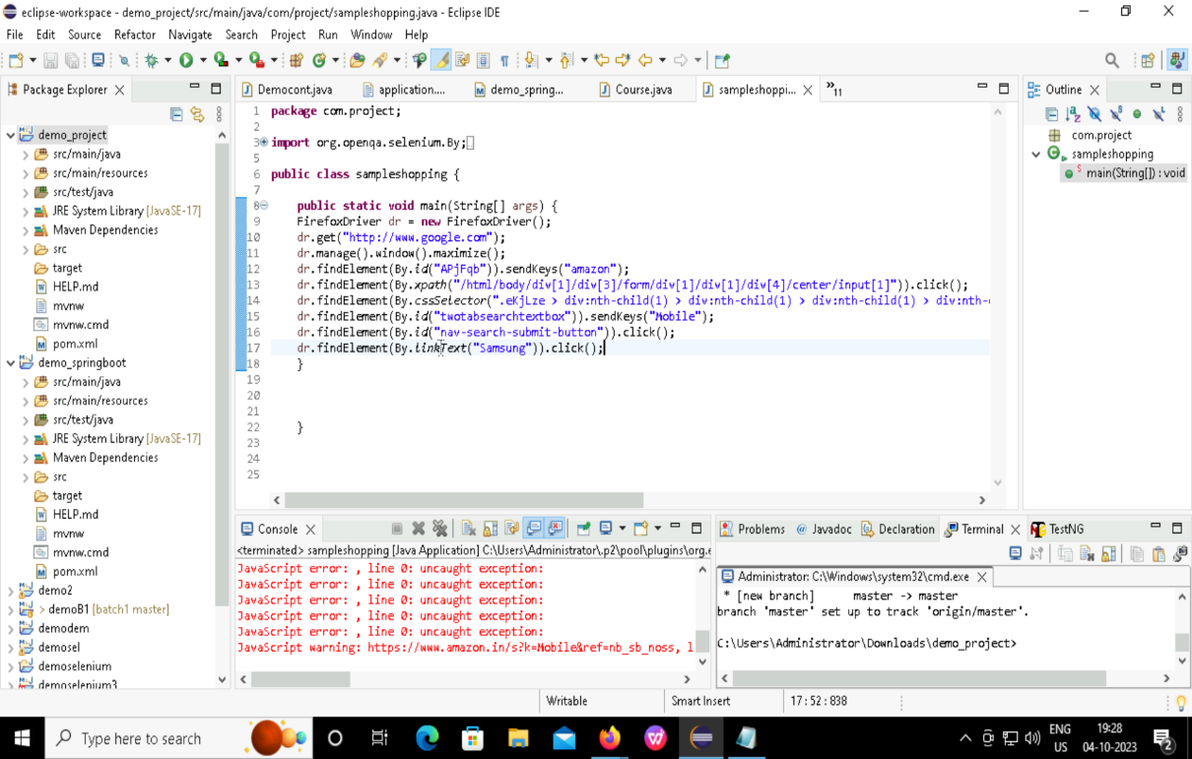

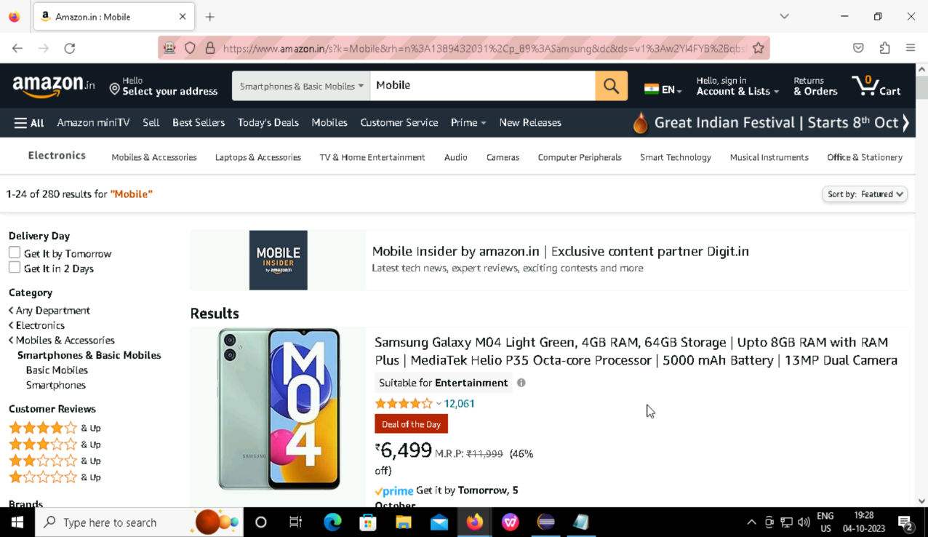

* Selecting the mobile and adding it to the cart.

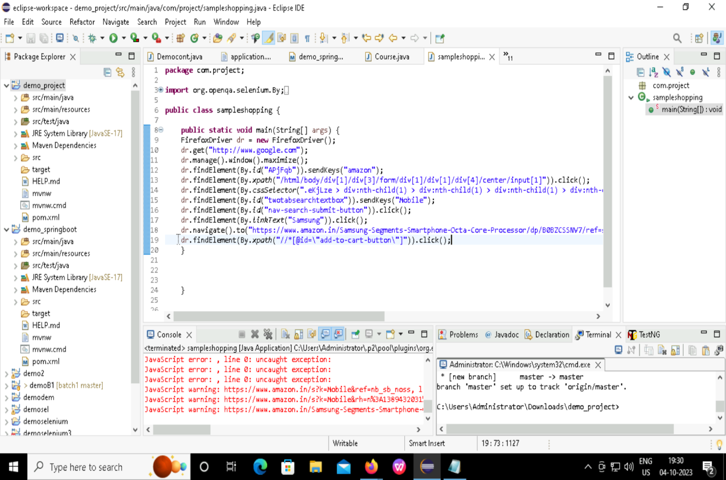

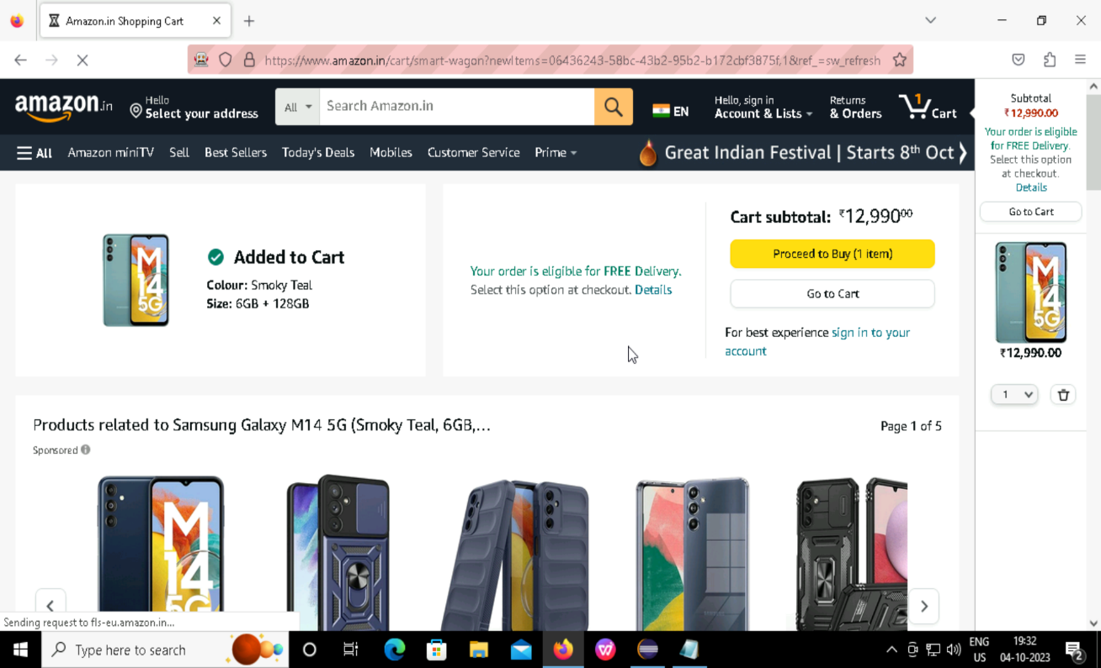

Spring Boot Initializer:

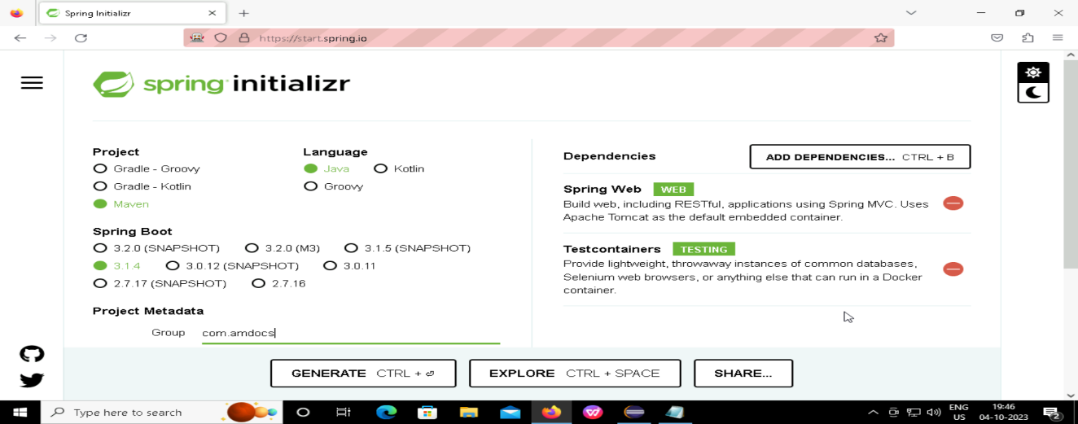

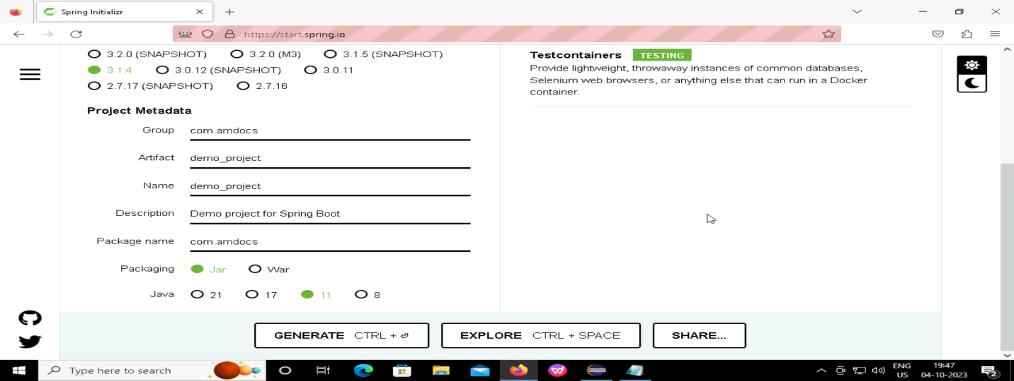

* Extracting the zip folder and importing it into eclipse:

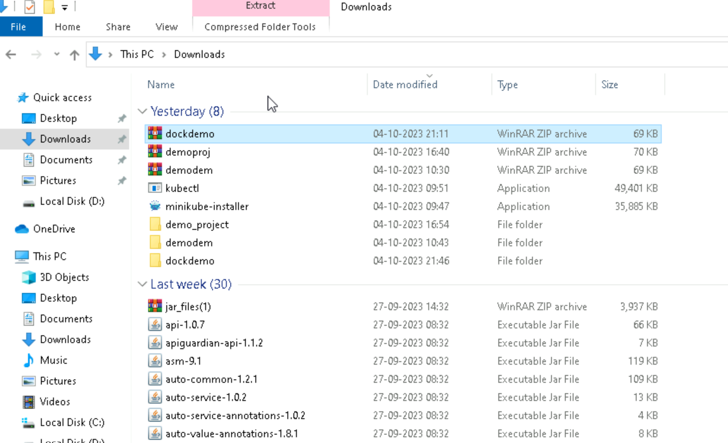

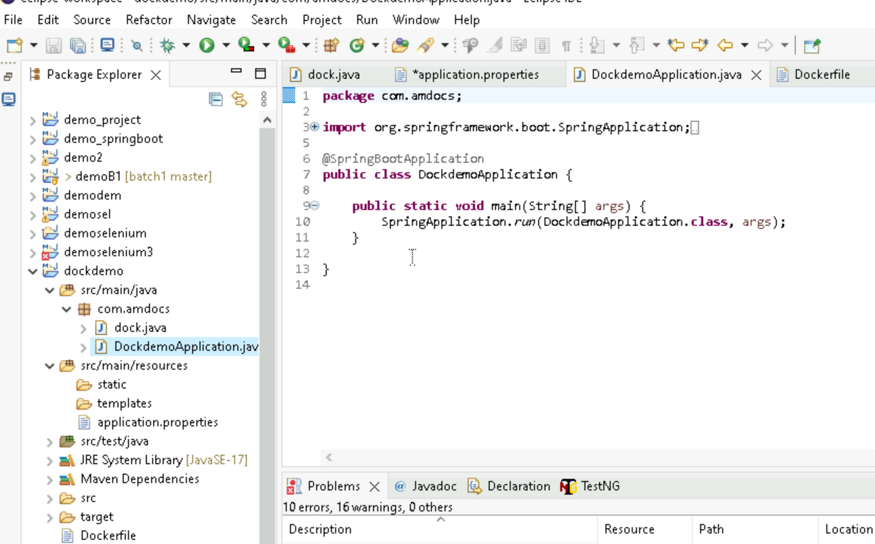

DOCKER:

* creating docker file writing the code, adding filename and running as maven install.

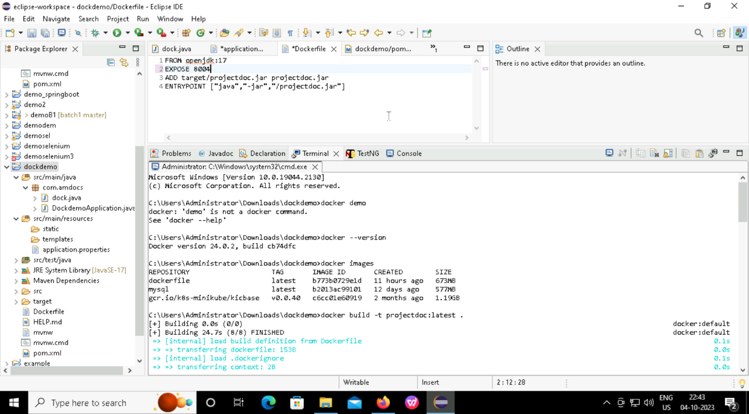

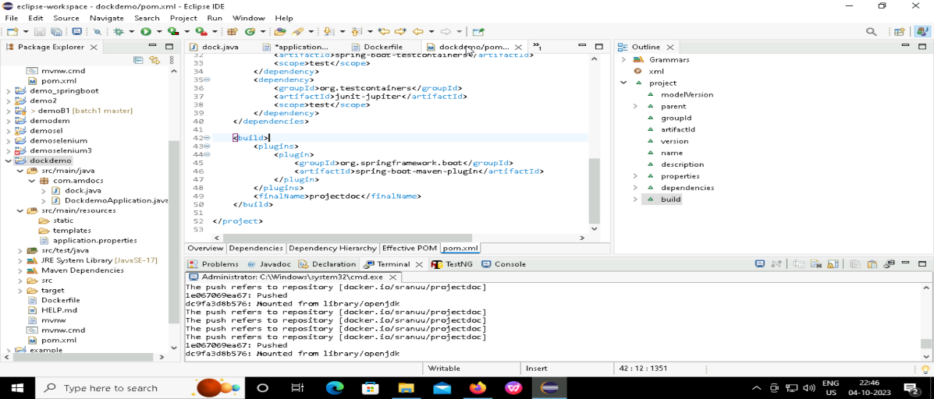

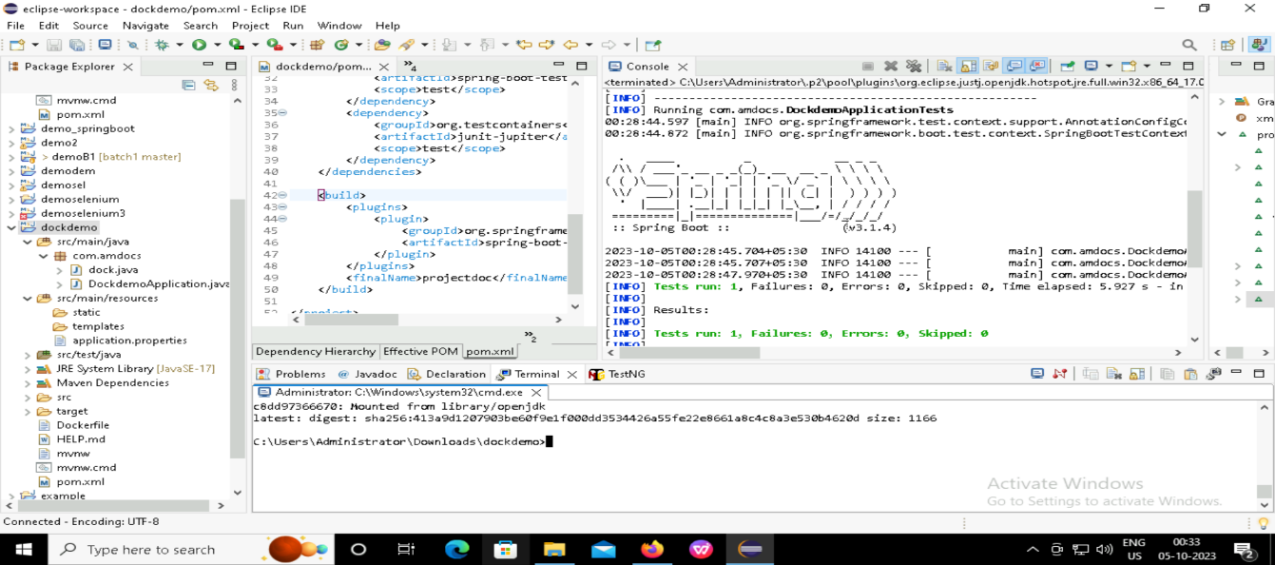

* Writing commands and running in docker.

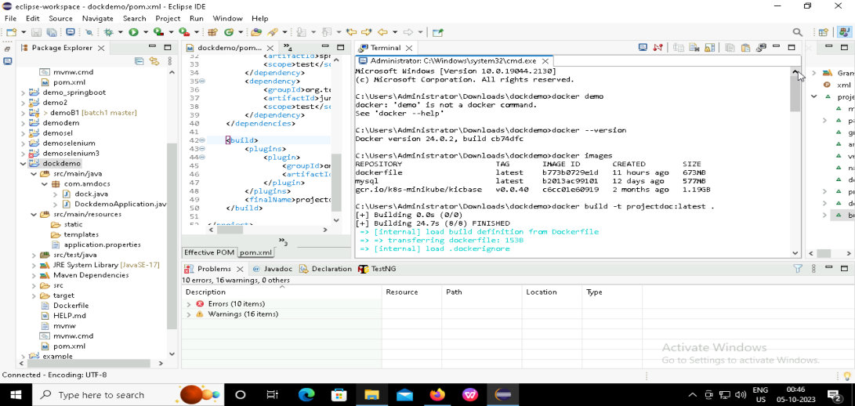

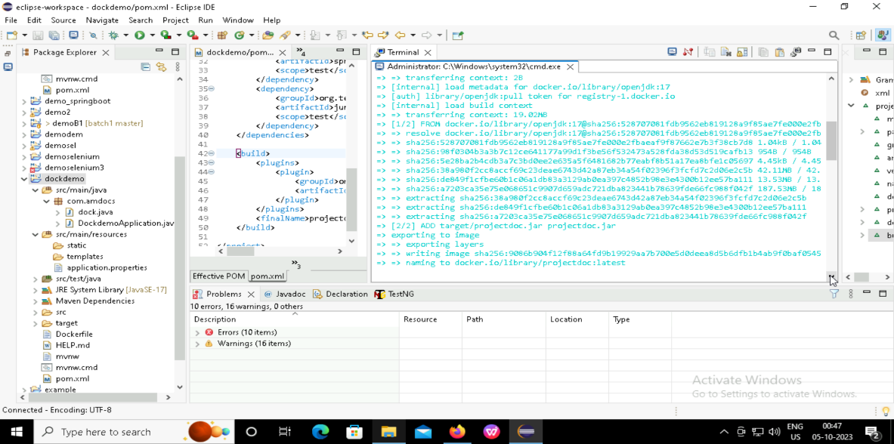

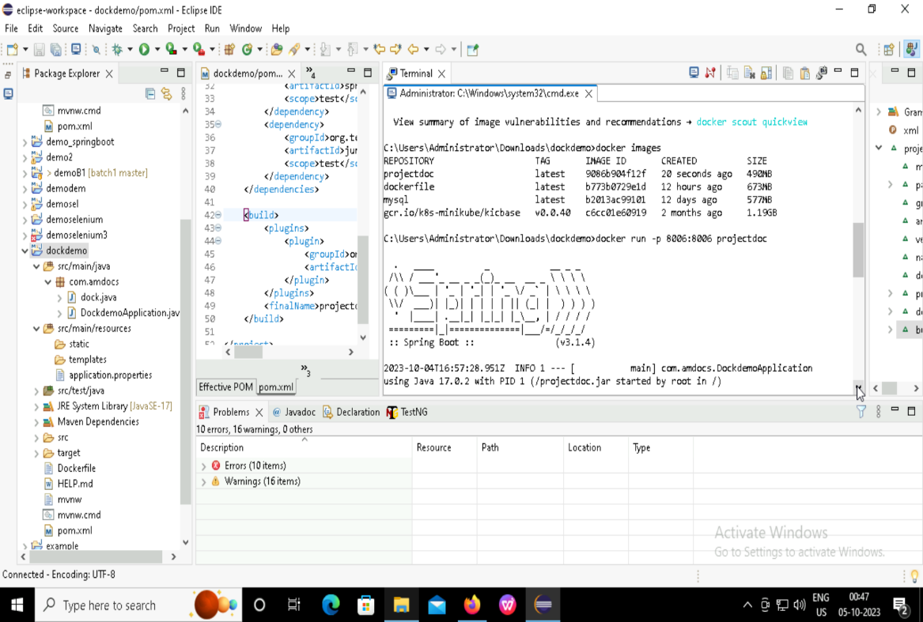

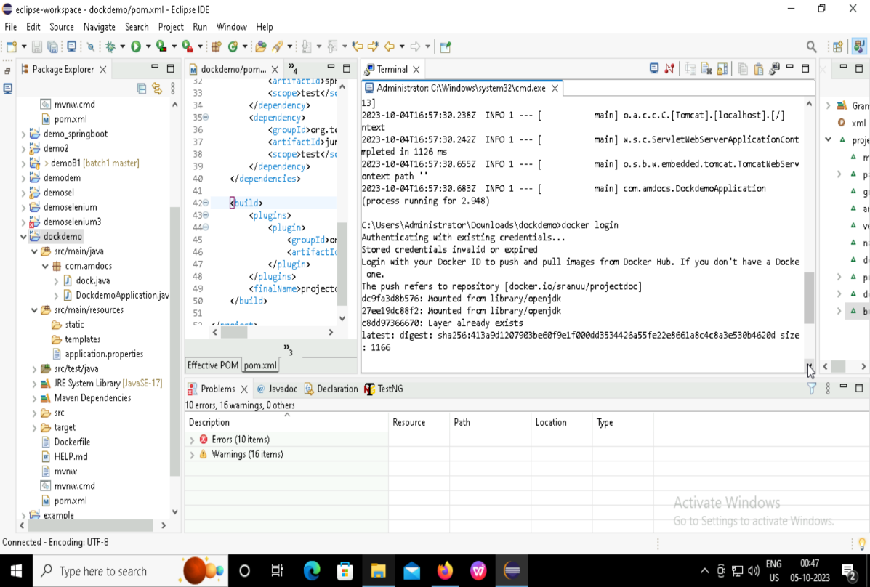

OUTPUT after pushing into docker:

